**PROBLEM STATEMENT**

|  |  |
| --- | --- |
| Date | 18 October 2022 |
| Domain Name | Internet of Things (IoT) |
| Project Name | ***SMART SOLUTIONS FOR RAILWAYS*** |
| Team ID | PNT2022TMID28701 |

**Example:**

# PS - 1

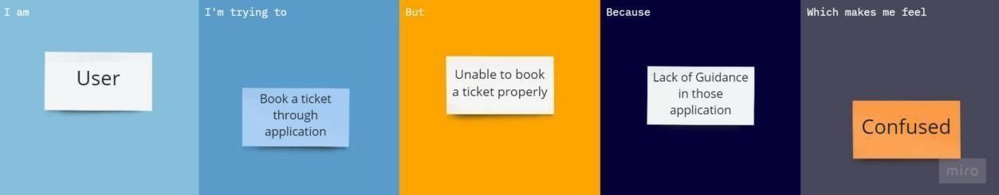

# PS – 2

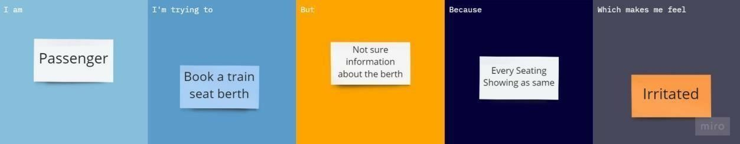

# PS – 3

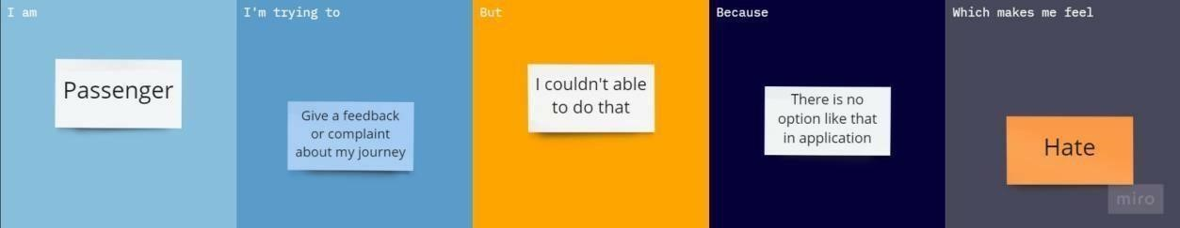

# PS – 4

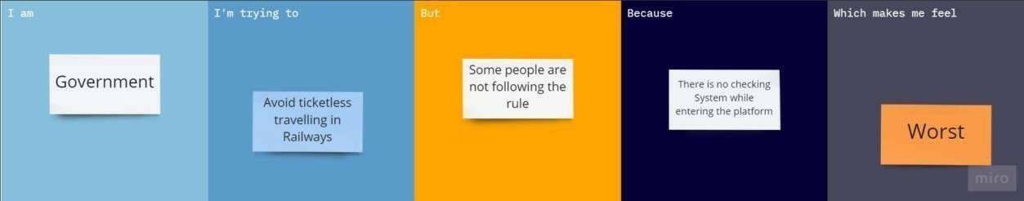

|  |  |  |  |  |  |
| --- | --- | --- | --- | --- | --- |
| **Problem**  **Statement**  **(PS)** | **I am**  **(Customer)** | **I’m trying to** | **But** | **Because** | **Which makes me**  **feel** |
| PS - 1 | User | Book a ticket through application | Unable to book ticket properly | Lack of Guidance in those application | Cofused |
| PS – 2 | Passenger | Book a train Seat Berth | Not Sure information about the berth | Evert seating showing as same | Irritated |
| PS – 3 | Passenger | Give a feedback or complaint about my journey | I couldn’t able to do that | There is no option like that in application | Hate |
| PS – 4 | Government | Avoid Ticketless traveling in Railways | Some people are not following the rule | There is no checking while entering the platform | Worst |

Reference:<https://miro.com/templates/customer-problem-statement/>